# Google Dorks

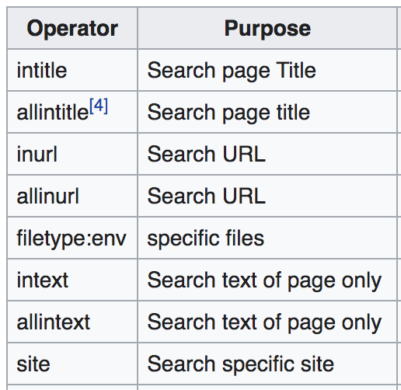

"Google hacking" involves using advanced operators in the Google [search engine](https://en.wikipedia.org/wiki/Web_search_engine) to locate specific strings of text within search results. Some of the more popular examples are finding specific versions of vulnerable [Web applications](https://en.wikipedia.org/wiki/Web_application).

<https://en.wikipedia.org/wiki/Google_hacking>

<https://www.exploit-db.com/google-hacking-database>

<https://blog.glugmvit.com/Google-Dorks-for-Recon/>

## Examples

| [intitle:"TOTOLINK" inurl:"/login.htm"](https://www.exploit-db.com/ghdb/6917) [Pages Containing Login Portals](https://www.exploit-db.com/google-hacking-database?category=12#) |
| --- |
| [intitle:"Current Network Status" "Nagios"](https://www.exploit-db.com/ghdb/6918) [Web Server Detection](https://www.exploit-db.com/google-hacking-database#) |
| [intitle:"index of" intext:"client.key.pem"](https://www.exploit-db.com/ghdb/6909)  filetype:pdf site:[www.bankofamerica.com](http://www.bankofamerica.com) |

## Exploit database

https://www.exploit-db.com/google-hacking-database

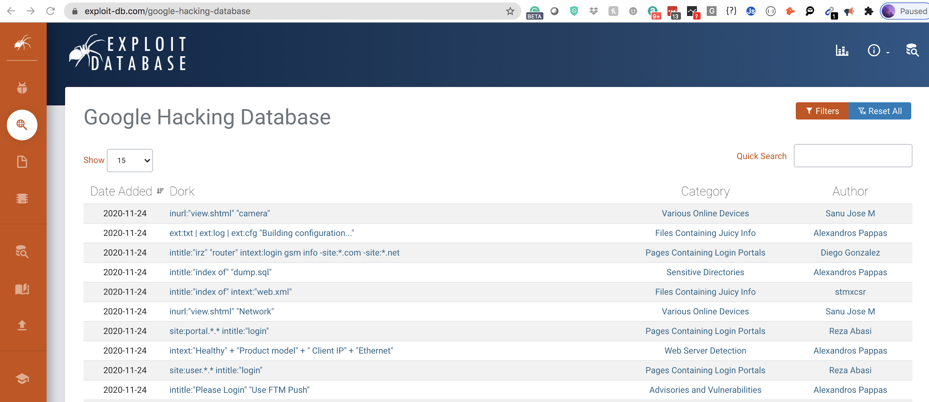

| 2022-01-12 | [site:vps-*.vps.ovh.net](https://www.exploit-db.com/ghdb/7840) | [Web Server Detection](https://www.exploit-db.com/google-hacking-database#) | [Chahine Boutighane](https://www.exploit-db.com/google-hacking-database#) |
| --- | --- | --- | --- |
| 2022-01-12 | [inurl:adminpanel site:gov.*](https://www.exploit-db.com/ghdb/7839) | [Footholds](https://www.exploit-db.com/google-hacking-database#) | [Asheet Tirkey](https://www.exploit-db.com/google-hacking-database#) |
| 2021-11-19 | [site:gov.* intitle:"index of" *.csv](https://www.exploit-db.com/ghdb/7834) | [Files Containing Juicy Info](https://www.exploit-db.com/google-hacking-database#) | [Midhun Mohanan](https://www.exploit-db.com/google-hacking-database#) |
| 2021-11-19 | [site:papaly.com + keyword](https://www.exploit-db.com/ghdb/7838) | [Files Containing Juicy Info](https://www.exploit-db.com/google-hacking-database#) | [Gabriel Tarsia](https://www.exploit-db.com/google-hacking-database#) |
| 2021-11-19 | [Fwd: intitle:"Index of /" intext:"resource/"](https://www.exploit-db.com/ghdb/7835) | [Files Containing Juicy Info](https://www.exploit-db.com/google-hacking-database#) | [Mugdha Bansode](https://www.exploit-db.com/google-hacking-database#) |
| 2021-11-19 | [Google to wordpress](https://www.exploit-db.com/ghdb/7836) | [Files Containing Juicy Info](https://www.exploit-db.com/google-hacking-database#) | [Aitor Herrero](https://www.exploit-db.com/google-hacking-database#) |
| 2021-11-19 | [Fwd: intitle:"atvise - next generation"](https://www.exploit-db.com/ghdb/7837) | [Files Containing Juicy Info](https://www.exploit-db.com/google-hacking-database#) | [Mugdha Bansode](https://www.exploit-db.com/google-hacking-database#) |
| 2021-11-18 | [inurl:admin filetype:xlsx site:gov.*](https://www.exploit-db.com/ghdb/7829) | [Files Containing Juicy Info](https://www.exploit-db.com/google-hacking-database#) | [Krishna Agarwal](https://www.exploit-db.com/google-hacking-database#) |
| 2021-11-18 | [inurl:"*admin | login" | inurl:.php | .asp](https://www.exploit-db.com/ghdb/7824) | [Pages Containing Login Portals](https://www.exploit-db.com/google-hacking-database#) | [Krishna Agarwal](https://www.exploit-db.com/google-hacking-database#) |
| 2021-11-18 | [intitle:index of settings.py](https://www.exploit-db.com/ghdb/7827) | [Files Containing Juicy Info](https://www.exploit-db.com/google-hacking-database#) | [Amit Adhikari](https://www.exploit-db.com/google-hacking-database#) |
| 2021-11-18 | [inurl:/intranet/login.php](https://www.exploit-db.com/ghdb/7826) | [Pages Containing Login Portals](https://www.exploit-db.com/google-hacking-database#) | [Diego Bardalez Plaza](https://www.exploit-db.com/google-hacking-database#) |
| 2021-11-18 | [inurl: /wp-content/uploads/ inurl:"robots.txt" "Disallow:" filetype:txt](https://www.exploit-db.com/ghdb/7831) | [Files Containing Juicy Info](https://www.exploit-db.com/google-hacking-database#) | [Ritwick Dadhich](https://www.exploit-db.com/google-hacking-database#) |
| 2021-11-18 | [site:postman.com + keyword](https://www.exploit-db.com/ghdb/7828) | [Files Containing Juicy Info](https://www.exploit-db.com/google-hacking-database#) | [Gabriel Tarsia](https://www.exploit-db.com/google-hacking-database#) |
| 2021-11-18 | [site:pastebin.com intitle:"cpanel"](https://www.exploit-db.com/ghdb/7825) | [Files Containing Juicy Info](https://www.exploit-db.com/google-hacking-database#) | [Ishani Dhar](https://www.exploit-db.com/google-hacking-database#) |
| 2021-11-18 | [inurl:admin filetype:xls](https://www.exploit-db.com/ghdb/7832) |  |  |